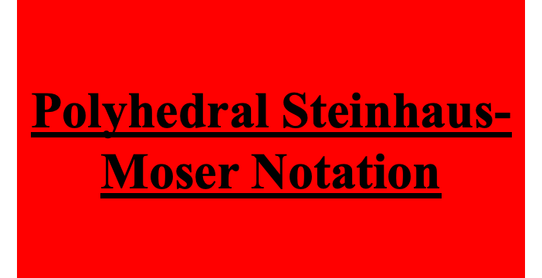



Polyhedral Steinhaus-Moser Notation

I was thinking about Steinhaus-Moser notation thanks to a 2025 Numberphile video posted by Dr. Tony Padilla and wanted to think of an interesting yet natural way of expanding the notation to even faster methods of growth. Of course, the most obvious way of doing that is to expand the notation to polyhedrons. I came up with the idea that each Polyhedron is an expansion of its polygonal equivalent :

Tetrahedron, pentahedron, hexahedron, etc.

Example: tetrahedron(2) which is the shape of a triangular pyramid = square(2) inside square(2) number of squares.
Now square(2) =

So tetrahedron (2) = 256 inside 256 squares

This number is far far bigger than Mega (pentagon(2))

Here is a rough approximation as to how gigantic this number is:

Googolplexplex . . . plex = 1 Layers
1 2 Googolplexplex . . . plex = 2 Layers
1 2 .
.
.
Googolplexplex . . . plex = 256 Layers
1 2 Googolplex

And this is just the smallest polyhedral operation with an integer > 1!

Tetrahedron(3) = square(3) inside square(3)

Now square(3) =

So tetrahedron(3) = 1.6 X 10⁴⁰ digits inside 1.6 X 10⁴⁰ digits number of squares!

Going even further, pentahedron(2) which is the shape of a square pyramid would be equal to Mega inside a Mega number of pentagons!

Hexahedron(2) is the shape of a cube.
Putting it in mathematical terms:
n-hedron(m) = n-gon(n-gon. . . n-gon(n-gon(n-gon(m))))
in which the number of layers of n-gons is n-gon(m).
Having a little too much fun, I came up with the Hyperion Moser. The Hyperion Moser is the polyhedral equivalent of a Hyper Moser. It is a two within a polyhedron whose number of faces is equal to the number of sides of the polygon that, when surrounding a two, equals a Hyper Moser.
In other words, a Hyperion Moser is a Hyper-Moser within a Hyper Moser number of Super Super Super. . . Super Moser-gons, in which the number of Supers is equal to a Moser.

